Name: B.Vinayani
Registration Number: 192472179

EXPERIMENT 1
Zero-shot, One-shot and Few-shot Prompts - Product Description for a Smart Fitness Watch

AIM
To design zero-shot, one-shot and few-shot prompts for generating a product description of a Smart Fitness Watch and to observe how the number of examples affects the generated text.

PROCEDURE
1. Open an LLM chat interface (such as ChatGPT, Gemini or Claude) in a new chat.
2. Zero-shot: enter an instruction that describes only the task (write a product description for a Smart Fitness Watch) without any example, and note the response.
3. One-shot: start a new chat and enter the same instruction together with ONE worked example, followed by the actual task. Note the response.
4. Few-shot: start a new chat and enter the same instruction together with THREE worked examples (two or three, as listed below), followed by the actual task. Note the response.
5. Capture a screenshot of each prompt with its generated output.
6. Compare the three outputs and record the observations.

PROMPTS (CODE)
Zero-shot prompt:
Write a product description for a Smart Fitness Watch.

One-shot prompt:
Write a product description in the same style as the example.

Example:
Product: Wireless Earbuds
Description: Experience music without limits. These lightweight wireless earbuds deliver crisp, balanced sound, active noise cancellation and 24 hours of battery life with the charging case. Sweat-resistant and secure in the ear, they are made for commutes, workouts and everything in between.

Now write for:
Product: Smart Fitness Watch
Description:

Few-shot prompt:
Write a product description following the format of the examples.

Product: Wireless Earbuds
Tagline: Music without limits.
Description: Lightweight earbuds with crisp sound and all-day comfort, built for commutes and workouts.
Key Features:
- Active noise cancellation
- 24-hour battery with charging case
- Sweat and splash resistant

Product: Insulated Steel Water Bottle
Tagline: Cold for a day, hot for a night.
Description: A durable double-wall bottle that keeps drinks at the right temperature wherever the day takes you.
Key Features:
- 24-hour cold, 12-hour hot
- Leak-proof lid
- BPA-free stainless steel

Product: Ergonomic Office Chair
Tagline: Comfort that works as hard as you do.
Description: A supportive chair that adapts to your posture so you can stay focused through long workdays.
Key Features:
- Adjustable lumbar support
- Breathable mesh back
- 360-degree swivel with silent wheels

Product: Smart Fitness Watch

OUTPUT
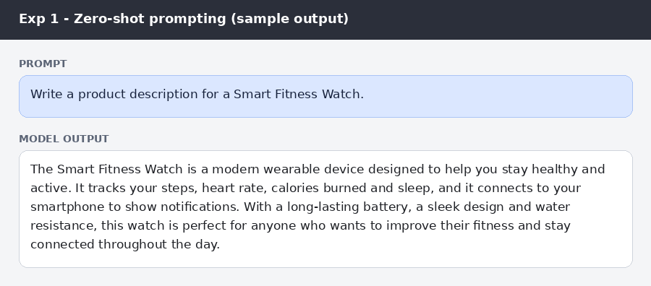
Figure: Zero-shot prompt and sample output
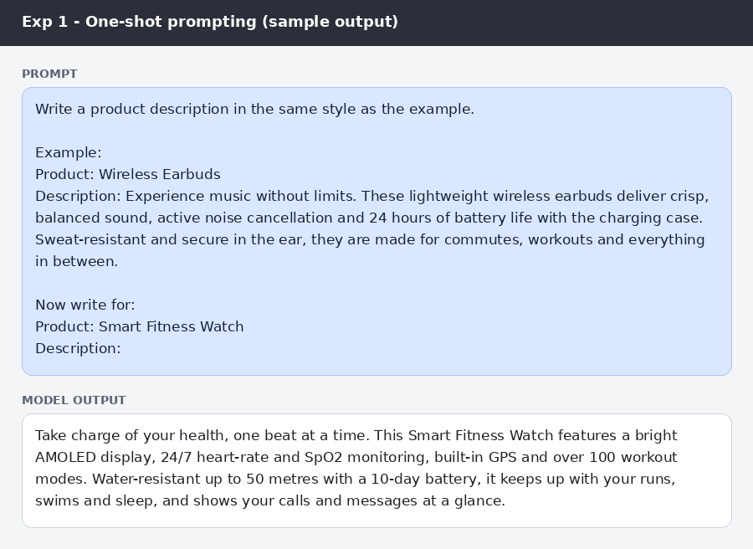
Figure: One-shot prompt and sample output
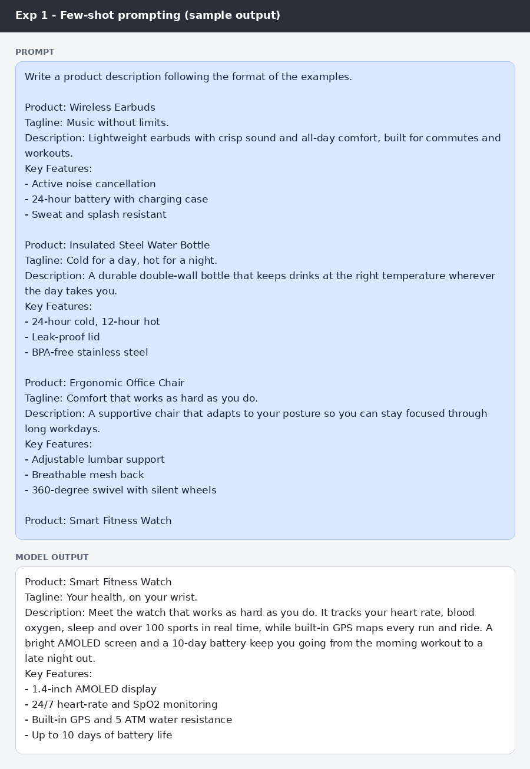
Figure: Few-shot prompt and sample output

RESULT
The zero-shot prompt produced a correct but generic description of 64 words with no fixed structure. The one-shot prompt produced a more persuasive description (58 words) that copied the tone and length of the example and included specific features. The few-shot prompt produced output in exactly the format shown in the examples: a tagline, a description and a list of key features.

CONCLUSION
Providing examples guides the LLM towards the desired tone, length and format. Zero-shot prompting is quick but gives generic text, one-shot prompting improves style matching, and few-shot prompting gives the most consistent and well-structured product description.

